Enfield Heights Academy Learning Web: Year 5 Autumn 2
Early Civilisations
Force for positive change:  This half term, children will explore the importance of acts of kindness and how they can help build positive relationships within our community. Through engaging discussions and activities, they will learn about the impact of small gestures and how to show kindness to others. Students will also participate in projects that encourage them to connect with their peers and the wider community, fostering empathy and collaboration.  We will also look at the importance of rivers and water sources for our society and what we can do to look after our rivers. |  |  |  | Key Dates:  Anti-bullying Week: 16/11/26, Children in Need- 13/11/26  Prime VR workshop 03.12.26, Winter Fair 4/12/26,  Christmas Jumper Day 16/12/26
  Maths  Children will learn to:  Fractions  -Identify, name and write equivalent fractions  -Compare and order fractions whose denominators are all multiples of the same number  Decimals  -Read and write decimal numbers as fractions.  ₋ Round decimals with two decimal places to the nearest whole number and to 1 decimal place.  -Solve real life problems involving the above  Percentages  - Recognise the % and meaning ‘parts per 100’  -Write % as fractions and decimals.  -Solve problems which require knowing percentage and decimal equivalents of one half, a quarter etc.  Measurement (time) & Statistics  -Solve problems involving converting between units of time.  -Complete, read and interpret information in tables, including timetables |  |  | English  Reading: In whole class reading, children, exploring a variety of text types designed to capture their interest and develop their comprehension ability.  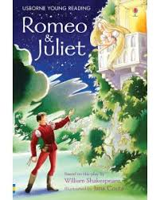  Writing:  Script: Children will write a script scene based on the story of Romeo and Julliet, using stage directions. They will study the layout and structure of scripts and how stage directions play an important role.  Newspaper article: Children will implement journalistic skills to write a newspaper report of the relationship split of Romeo and Julliet, using direct and reported speech. |  |  | Music  This term, children will be learning and developing a range of singing techniques leading to a performance.  They will explore soul music and its origins and discuss themes and emotions of different songs.  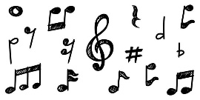
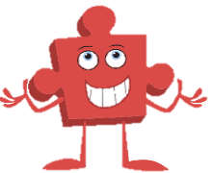  PHSE: Celebrating Differences  This term, children will be celebrating differences across the world, investigate different cultures around the world and learn about stereotypes. |  | Physical Education  PE – Outdoor - NFL  The children will apply their prior learning of passing and moving, to help them to execute different passes and understanding where, when they are used in a game. Children will be able to develop tactics for both attacking and defending and apply these successfully within their team.  PE- Indoor – Gymnastics  Children will have the opportunity to Develop flexibility, strength, technique, control, and balance.  They will also be able to compare performances with previous ones and demonstrate improvement to achieve their personal best. |  |  |  |   Spanish  This term, the children will be identifying and describing different types of foods.
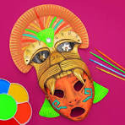  Art: Multimedia  Children will analyse Mayan mask designs before designing their own. They shall then make the mask and evaluate it once completed. |  |  |  |  |  | DT:  Children shall be analysing ancient shelters and evaluating them before proceeding to design and create their own.
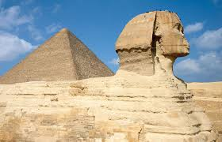  History  This term we will be looking at Early Civilisations: Ancient Sumer, Mayans, Shang dynasty, Ancient Egypt, Indus Valley  The children will compare aspects of life between the different civilisations as well as their impact on modern life. | Geography: Rivers  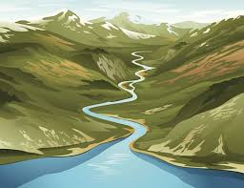  This term, children will develop key geographical skills, starting with identifying the 8 compass points and applying them to locate countries in relation to the UK. They’ll explore ancient civilizations, learning to identify their locations and the significance of rivers to their development.  The enquiry focuses on rivers, covering their formation, stages, and the benefits and hazards of living near them. Students will analyse the historical and modern importance of rivers, culminating in answering the question: What are rivers, and why are they important to us? |  |  |  | Science: Changes of Materials  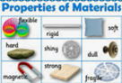  This term children will be learning about different types of materials.  They will be conducting a range of experiments to discover the properties and changes of various materials and will be evaluating their findings.

